# RStudio Cloud

These are directions to set up RStudio cloud so that it will run like DataCamp Sandbox in CourseKata’s statistics course.

1. Sign up for an account on RStudio cloud.
2. Go to this template class: <http://bit.ly/coursekata_rstudiocloud>

* It will be “deploying project” for a few minutes.

1. At the top, it will say this is a “temporary project” because this is my project rather than yours. However, you can “Save a Permanent Copy” and then you will have a copy that is purely yours.



* It may take a while to set up this permanent copy.

1. Once it sets up, you probably want to change the name of this project to something that helps you. Just click on the name and you’ll be able to edit it. For example, my own project is named for my course (PSY3020_Fall19).



1. In RStudio Cloud, think of a “project” (like the one you just set up) as “your computer” (it’s really an environment). You don’t want to start a project every time you log in to RStudio. Next time, you can just login to RStudio.cloud and click on this project. It will be ready to go!
2. To orient you to RStudio, on the lower right side, there are a number of files in this project. You want to click on **sample_class.Rmd** to open it. Rmd stands for R-markdown file which is a file that combines text, blocks of R code, and the results of that R code.

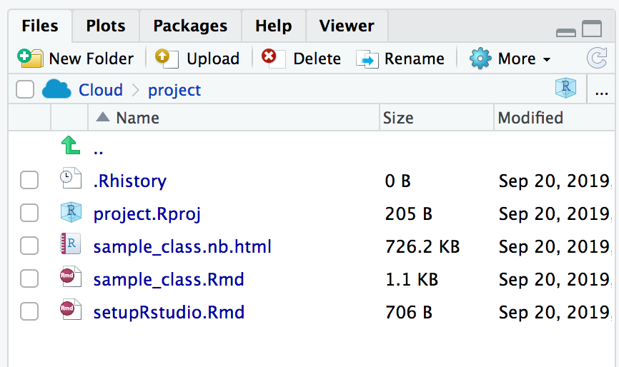

1. The **sample_class.Rmd** file has further instructions. Try running the code blocks (you have to run the code block that loads the libraries first).
2. If you want your students to copy this template, they can follow the same directions.